QUALITY ASSURANCE IN ESP IN
HIGHER EDUCATION

Laura-Mihaela Muresan, PhD, Univ. Prof.
Bucharest Academy of Economic Studies

Abstract:

The article addresses Quality Assurance and ESP related questions from various perspectives, in an attempt at highlighting the inter-connectedness among domains and the inter-play between the macro- and micro-levels. While there is not one right answer, we will argue that possible solutions depend on which questions we ask and where we set our priorities. For exemplification purposes, reference will be made to case studies from various academic contexts, to quality assurance systems in language education (e.g. EAQUALS and QUEST Romania) and to Council of Europe projects (e.g. "QualiTraining").

Setting the Scene

There are various ways of looking at Quality Assurance (QA) in ESP in Higher Education (HE), depending on the main purpose of the research venture or the practical rationale for this. Hence a number of aspects that can be investigated and possible perspectives to be taken, challenges to be considered and ways of improving quality to be explored.
Thus, to give just a few examples, we may consider this whole theme within the general HE context and the framework provided by developments in QA in tertiary education at macro level – both national and European.
Another perspective would be the embedding in the institutional environment, taking into account factors such as organizational culture, institutional language policy, the inter-play with QA procedures in other subject fields in the university, and the current focus on academic research.
If we change the perspective from ESP as one subject field within the HE environment – whether at macro/national or micro/institutional level – to ESP as a component part of language education, then we may regard it in its relationship with other comparable contexts, e.g. (a) language centres and other professional organizations in the field, (b) quality assurance systems developed at national and European level, with a focus on improving the provision of language services, as well as (c) concepts, instruments and procedures developed at European level for promoting pluri-lingualism and for more consistency of approach in addressing language teaching, learning and assessment, irrespective of the language learned – e.g. The Common European Framework of Reference for Languages (Council of Europe, 2001), The European Language Portfolio (EAQUALS-ALTE, 2000).
Following on from this contextualization within language education, we could also look at the inter-relatedness between QA processes and targeted Professional Development and Life Long Learning for teachers/academics, including areas such as quality management, practice-based research, etc.
Before we start elaborating on QA in ESP in HE, we would also need to clarify what dimensions of quality we are most interested in, and which weighting we want to give to the ‘S’ in ESP. What are the main aims that we associate with ESP? How do we understand our role as teachers and how do we view our learners?
Without aiming at covering all possible aspects, the following diagram is an attempt at synthesising some of the main themes and issues mentioned above.

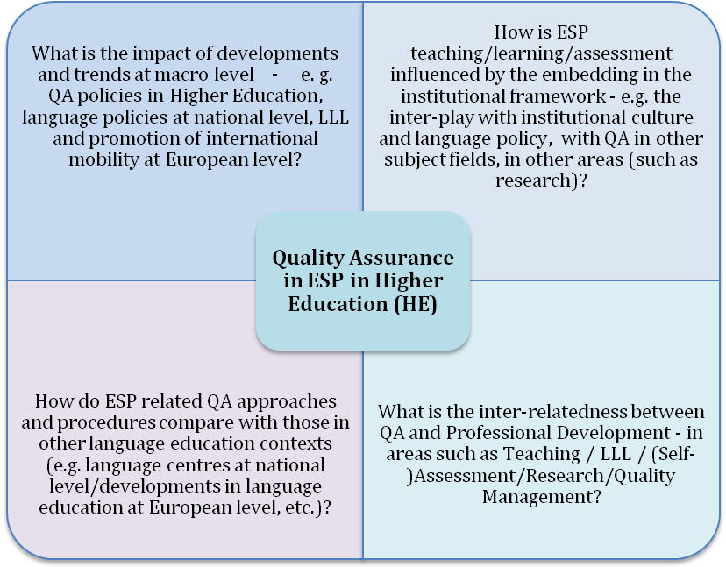

Beyond the diagramatic simplification, there are, of course, multiple links among the areas and aspects entered above. With the preoccupation for compliance with the stipulations of the Bologna process, developments at macro-level and concerns for institutional accreditation have a growing impact on processes within universities, at all levels and in all fields and sub-fields. At the same time, language policies at European level, an increased focus on life-long learning (LLL) and QA in general, as well as developments in the approach to key-competencies (as defined by the EU) trigger a re-newed interest in both institutional and individual learning. All these throw new light on the value of interdisciplinarity and the need for multiple partnerships and co-operation at all levels. At the same time, they rekindle everybody’s interest – the students’ and the teachers’ alike - in developing and improving transferrable skills and competences for career and life.

Quality Assurance in English-medium Programmes - examples from Western universities

In addition to the formal aspects of the Bologna Reform, leading to a macro-level restructuring of HE to implement the new three-plus-two model, there is also the pressure put on universities "to foster general competencies and qualities such as professional and ethical responsibility, critical thinking and accountability for one's own learning, communication skills in excess of comprehensive content knowledge of the subjects at hand." (Räisänen and Fortanet-Gomez, 2008:1).
What does this entail for ESP in HE? In a context favouring competitiveness among universities, there are more and more English-medium programmes, both at Bachelor and at Master level, with ESP becoming an important part and a pre-requisite of Content and Language Integrated Learning (CLIL).
Which are the implications for Quality Assurance in institutional settings? How is it approached in Western Universities with expertise in this field? Here are two examples from Northern Europe, to illustrate their approach to QA, reflecting also their awareness of the challenges involved.
At the University of Jyväskylä in Finland, for instance, they embarked on the institutional evaluation of the English-medium Masters programmes (Räsänen, 2008). This was carried out as an internal institution-wide evaluation, commissioned by the Rector of the university, to identify elements needing special attention from a quality assurance point of view, to share examples of good practice and to readjust criteria for evaluation and further development. The approach was collaborative, action-research-based, involving a lot of actors - programme co-ordinators, teachers, students. The main areas focused on were:
- implementation of the university's language policy
- implementation of "content and language integrated programmes", and related aspects, such as areas of student challenges, intercultural issues, skills development
- coherence and consistency of approach among the various programmes, in terms of documentation, infra-structure, policy formulation at institutional level (e.g. re language requirements, comparability of assessment and evaluation, staff development).

At the University of Oslo, Norway, QA was approached primarily from the students' perspective (Hellekjaer, 2008). The research question was: What were the main difficulties students were facing in terms of listening comprehension and oral proficiency in English-medium courses', both at a conceptual and a terminological level? And if the students were confronted with challenges, what were the causes? Although the evaluation focused primarily on two skill areas, it was designed and carried out as a complex process, involving observation, interviews, tests, comparative studies (e.g. comprehension in English as compared to mother-tongue, comparisons among findings in various subject areas), analysing teacher competencies (pedagogical versus English language competencies). The findings of the study helped the university refine their language policies and provided the instruments and framework for extending the evaluation to cover the English-medium programmes in more subject areas.
Also further case studies from Western academic settings (e.g. from universities in the Netherlands, Klaassen, 2008) illustrate the importance attached to feedback from the grassroots level in refining decision taking regarding educational processes. The literature in the field and discussions with professionals reveal preoccupations for enhancing the quality standards of HE in the new 'post-Bologna' context. Therefore, in order to frame developments in ESP, it is important to consider it in its inter-relatedness with EAP, and with emerging priorities at European level and at institutional level.

Post-Bologna developments in HE in our context

Implications for the institutional level in our Romanian context are not very different. There is an increased interest in introducing English-medium programmes or at least English language modules and courses. In parallel, there are preoccupations for enhancing the status of our universities as research universities, of involving academics and students in research projects, and giving them international visibility. All these bring about a need for
- more teachers / academics with advanced English language competencies, with expertise of teaching their subject in English and of carrying out research at international standards
- students with English language skills willing and prepared to take courses in English
- institutional policies and quality assurance criteria for monitoring educational processes and evaluating their effectiveness and compliance with international standards
- systems in place for ensuring that ESP and CLIL integrate also other dimensions of the Bologna process, e.g. related to enhanced employability for the students, their developing key-competencies and skills for life, transferrable to various professional settings.

Linking Teacher Development with Quality Assurance - A case study from the Bucharest Academy of Economic Studies

To illustrate how Professional Development for teachers / academics is integrated with Quality Assurance, in response to both institutional and individual needs, we may consider the interdisciplinary Research and Teacher Education Masters programme at the Bucharest Academy of Economic Studies, introduced in 2006. It is an English-medium programme - "English Language Education and Research Communication for Business and Economics" - with multiple aims: (i) improving teaching methodology, with a focus on CLIL in HE for business and economics; (ii) facilitating the participants' improving their English language proficiency and communication skills, for both teaching and research purposes; (iii) enhancing the quality of research in terms of methodological aspects and presentation/publication of research outcomes internationally.
The interdisciplinary dimension, the curriculum and the methodological approach, are meant to let the participants experience a different way of teaching, learning and (self-) evaluation. Networking with colleagues of other specialisations is encouraged, as well as thinking outside the box, taking the challenge of exploring aspects outside one's own subject field. One of the outcomes - an added value of this programme - is that of achieving more consistency and coherence of approach in terms of quality assurance across disciplines (for more details on the programme, see also Muresan, 2008).
What does it entail for ESP/EAP teaching and learning? If we take the perspective of ESP teachers participating as students in this Masters, it means opening up new interdisciplinary perspectives and an increased awareness of what is needed in the 'real world', including the 'real academic world' typical of other subject fields in business and economics. It also means skills development in areas such as critical thinking and creative thinking, as well as advanced EAP skills, which they can then apply in their own ESP class; practical aspects of educational management and quality assurance (module based on the ECML "QualiTraining" project (Muresan, Heyworth, Mateva and Rose, 2007), applicable to their own teaching context; experiencing interdisciplinary project work, usually taken further also outside the programme framework and multiplied in work with their own students, thus adding new dimensions to ESP learning.
If we take the perspective of the academics involved on the teaching side, it is definitely a challenging experience, at the same time rewarding and confidence-building. As we can see also from other academic contexts, ESP/EAP teacher trainers can bring their contribution to the transfer of expertise relevant also to other specialisations and, thus, to the quality enhancement of educational processes within the university.

Pulling the strings together

To address Quality Assurance issues in ESP in Higher Education in an institutional context, there are multiple perspectives we could take, and it would be difficult to find one overall solution. We would, therefore, need first to take a co-operative approach to discuss and - hopefully - agree on aspects such as: What is a good lesson? What are the main objectives of HE - in our institutional context? Which priorities should guide us in developing strategies for ESP in our university? Which are our benchmarks?
Depending on how we define quality and the underlying principles we value most, we may want to focus on outcomes of HE or on the process leading to learning outcomes, or we may want to consider "value-driven" quality (Heyworth, 2007) as our guiding principle. The way we formulate our main objectives, will frame our key-criteria in developing strategies for our educational programmes and the mirror against which to evaluate them.
Why is the co-operative approach essential in this whole endeavour? Quality Assurance means more than the quality of a course or the high quality standards of a teacher. It involves having systems in place for ensuring consistency and coherence of approach, as well as transparency of objectives and procedures. This implies that the policies formulated by the top management are visible also to the grassroots level and that the objectives are achievable. It also implies that there is agreement among teachers and between teachers and students regarding the objectives of ESP. For instance, what is essential, the "S" (i.e. the specialisation), e.g. for employability reasons, or the link with EAP (English for Academic Purposes), including international mobility? Is the learning-to-learn dimension more important, as it helps students integrate all new learning expriences, capitalising on transferrable skills, even in unexpected situations?
Any Quality Assurance venture - wether an internal evaluation exercise or external control - starts from the objectives, as formulated by the institution, to see if they are known to all the stakeholders, if there are systems in place to facilitate their implementation and communication, and if educational practice is in line with these objectives.
Quality Assurance systems in the field of language education, such as EAQUALS - The European Association for Quality Language Services (www.eaquals.org), the national association QUEST Romania - The Romanian Association for Quality Language Services (www.quest.ro), provide useful frameworks for a comprehensive and integrative approach to Quality Assurance, even if they do not focus specifically on one language or one domain within language education. Similarly, instruments developed at European level, such as the CEFR (Council of Europe, 2001) and the ELP (EAQUALS-ALTE, 2000), help not only with diagnosing the level of language proficiency, but also with the formulation of institutional language policies, the setting of both strategic goals and specific learning objectives, standardising methodological approaches, etc.
As a reflection of growing interest in implementing quality assurance at all levels, empowering institutions and individuals to be aware of what it entails and to contribute to informed decision-taking, there are more and more European projects focusing on this area and developing instruments to facilitate the consolidation of a "quality culture" approach in language education (Rose, 2007). To name just a few examples from the ECML / Council of Europe framework: the "QualiTraining" projects and the QualiTraining Guide (Muresan, Heyworth, Mateva and Rose, 2007), the European Portfolio for Student Teachers of Languages (Newby et al., 2007).

References
Council of Europe (2001), Common European Framework of Reference for Languages: Learning, Teaching, Assessment, Cambridge: Cambridge University Press & Council of Europe
EAQUALS and ALTE (2000), The EAQUALS-ALTE European Language Portfolio. Milano: Lang Edizzioni; on-line version available at www.eELP.org
Hellekjaer, G.O. (2008), "Quality Issues in English-Medium Instruction: Norwegian Students' Aural and Oral Proficiency in Non-elective Courses", presentation at the 15th World Congress of Applied Linguistics - AILA 2008: Multilingualism: Challenges and Opportunities, Essen, 24-29 August 2008
Heyworth, F. (2007), "Quality Principles and Basic Concepts" in
Muresan, L., F. Heyworth, G. Mateva and M. Rose (2007)
Klaassen, R. (2008), "English Language Policy Changes as a Result of Testing Scientific Staff at Delft University of Technology", presentation at the 15th World Congress of Applied Linguistics - AILA 2008: Multilingualism: Challenges and Opportunities, Essen, 24-29 August 2008
Muresan, L. (2004), Monitoring Professional Development in an Educational NGO, Bucuresti: Punct
Muresan, L., F. Heyworth, G. Mateva and M Rose (2007), QualiTraining - A Training Guide for Quality Assurance, Strasbourg: Council of Europe Publishing (on-line version available at www.ecml.at)
Muresan, L. (2008) "Promoting a Quality Culture at Grassroots Level
in Higher Education" in Theoretical and Applied Economics Supplement: Change Leadership in Romania's New Economy/2008
Newby et al. (2007), European Portfolio for Student Teachers of Languages, Strasbourg: Council of Europe Publishing (on-line version available at www.ecml.at)
Räisänen, C. and I. Fortanet-Gomez (2008), "The State of ESP Teaching and Learning in Western European Higher Education after Bologna" in Fortanet-Gomez, I. and C. Räisänen (Eds), ESP in Higher Education, Amsterdam/Philadelphia: John Benjamins Publishing
Räsänen, A. (2008), "Evaluating Content and Language Integrated Programmes in HE", presentation at the 15th World Congress of Applied Linguistics - AILA 2008: Multilingualism: Challenges and Opportunities, Essen, 24-29 August 2008
Rose, M., (2007) "Quality and People" in Muresan, L., F. Heyworth, G. Mateva and M. Rose (2007)

